**EMPATHY MAP**

|  |  |
| --- | --- |
| **DATE** | **16.03.2023** |
| **TEAM ID** | **NM2023TMID13094** |
| **PROJECT** | **A reliable energy consumption analysis system for energy efficient appliances** |

* **What he sees:**
  + he sees that there is a growing concern among consumers about energy consumption and its impact on the environment.
* He sees that there are many energy-efficient appliances available in the market, but consumers are often unsure about how much energy they are actually saving by using them.
* **What he hears:**
* He hears from consumers that they want to reduce their carbon footprint and save money on their energy bills, but they don't know where to start.
* He also hears from energy companies that they want to promote energy-efficient appliances and reduce overall energy consumption, but they need more data and analysis to make informed decisions.
* **What he thinks and feels:**
* He is concerned about the environmental impact of excessive energy consumption and wants to help consumers make more informed choices.
* He feels that there is a lack of reliable data and analysis available to both consumers and energy companies, which is hindering progress in this area.
* He believes that an energy consumption analysis system for energy-efficient appliances could be a valuable tool to address these issues.
* **What he does:**
* he conducts research on energy consumption and energy-efficient appliances to stay up-to-date on the latest trends and developments.
* He works with consumers and energy companies to gather feedback and insights about their needs and pain points.
* He collaborates with engineers and data analysts to develop and test an energy consumption analysis system that meets the needs of both consumers and energy companies.
* **Pains:**
* 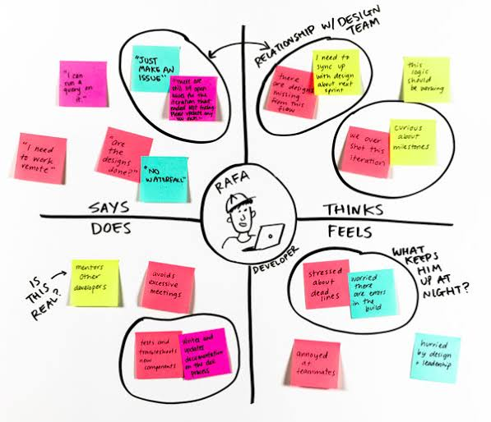 He feels frustrated that there is a lack of reliable data and analysis available to both consumers and energy companies, which is hindering progress in this area.
* He is concerned that consumers may not see the value in an energy consumption analysis system and may not be willing to invest in it.
* He worries that energy companies may not be willing to share their data and may see the system as a threat to their business.
* **Gains:**
* excited about the potential impact of an energy consumption analysis system on reducing overall energy consumption and promoting energy-efficient appliances.
* He feels that the system could help consumers make more informed choices and save money on their energy bills.
* He believes that energy companies could use the system to optimize their operations and reduce costs.